Project Design Phase-II
Data Flow Diagram & User Stories
Date | 01 October 2026
Team ID | [Enter your Team ID]
Project Name | Blog Nest – AI-Powered Blogging & Content Management Backend
Maximum Marks | 4 Marks

Data Flow Diagrams:
The Data Flow Diagram shows how data enters and leaves Blog Nest, which processes transform it, and where it is stored. External entities are the four user roles and Google Gemini AI. Data stores hold users, posts (with categories and tags) and comments.
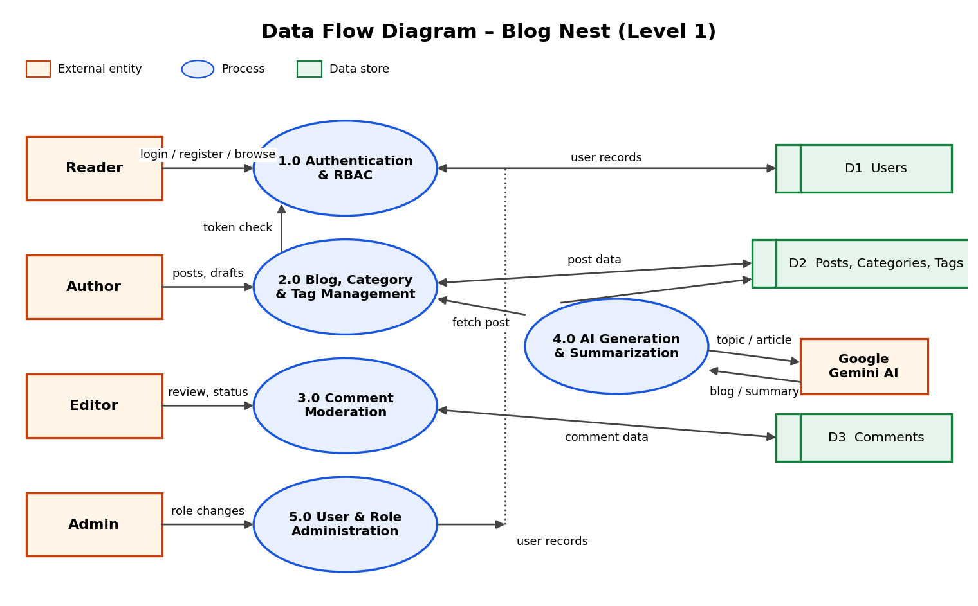
Figure 1: Level-1 Data Flow Diagram of Blog Nest
User Stories
User stories for the product are listed below.
User Type | Functional Requirement (Epic) | User Story Number | User Story / Task | Acceptance criteria | Priority | Release
Admin / All users | Registration & Login | USN-1 | As a user, I can register by entering my name, email and password. | Account is created and I receive a confirmation response | High | Sprint-1
 |  | USN-2 | As a user, I can log in with my email and password and receive a JWT token. | Valid credentials return a token; invalid credentials are rejected | High | Sprint-1
 |  | USN-3 | As a user, my password is stored securely. | Password is saved as a bcrypt hash, never in plain text | High | Sprint-1
Admin | Role Management | USN-4 | As an admin, I can assign and change user roles. | Role change is saved and enforced on the next request | High | Sprint-1
Author | Blog Management | USN-5 | As an author, I can create a blog post as draft, scheduled or published. | Post is saved with the chosen status | High | Sprint-2
 |  | USN-6 | As an author, I can edit and delete my own posts. | Only the owner (or admin) can change or delete the post | High | Sprint-2
 | Categories & Tags | USN-7 | As an author, I can assign categories and tags to a post. | Post appears under its categories and tags | Medium | Sprint-2
 | Media | USN-8 | As an author, I can attach image/media metadata to a post. | Media path and metadata are stored with the post | Low | Sprint-2
 | AI Assistance | USN-9 | As an author, I can request an AI-generated blog from a topic. | Gemini returns a structured blog post | High | Sprint-3
 |  | USN-10 | As an author, I can request an AI summary of a long article. | A concise summary is returned | High | Sprint-3
Reader | Browse & Search | USN-11 | As a reader, I can browse published posts without logging in. | Published posts are returned; drafts are hidden | High | Sprint-2
 |  | USN-12 | As a reader, I can search posts by keyword, category or tag. | Matching posts are listed | Medium | Sprint-2
 | Comments | USN-13 | As a reader, I can comment on a published post when logged in. | Comment is saved with status pending | Medium | Sprint-3
Editor | Review & Moderation | USN-14 | As an editor, I can review pending posts and change their status. | Status updates to published or back to draft | High | Sprint-3
 |  | USN-15 | As an editor/admin, I can mark comments as approved, pending or spam. | Only approved comments are shown publicly | High | Sprint-3

